

|  |  |  |
| --- | --- | --- |
| Mathematics Department | |  |
| Course: ATMAA | |
| Topic Title: Networks and Decision Mathematics  Test 6 | |
| Student Name:_____________________________________ | Date: ____________ | | |
| Special Instructions: **Calculator Allowed**  **1 page of A4 notes and Formula Sheet Allowed** | Time Allowed: 50 mins | | |
|  | Marks: / 42 | | |

**Question 1.** **[4, 4, 4: 12 marks]**

The network below show distances (in km), between the various towns in the north of the New South Wales state.

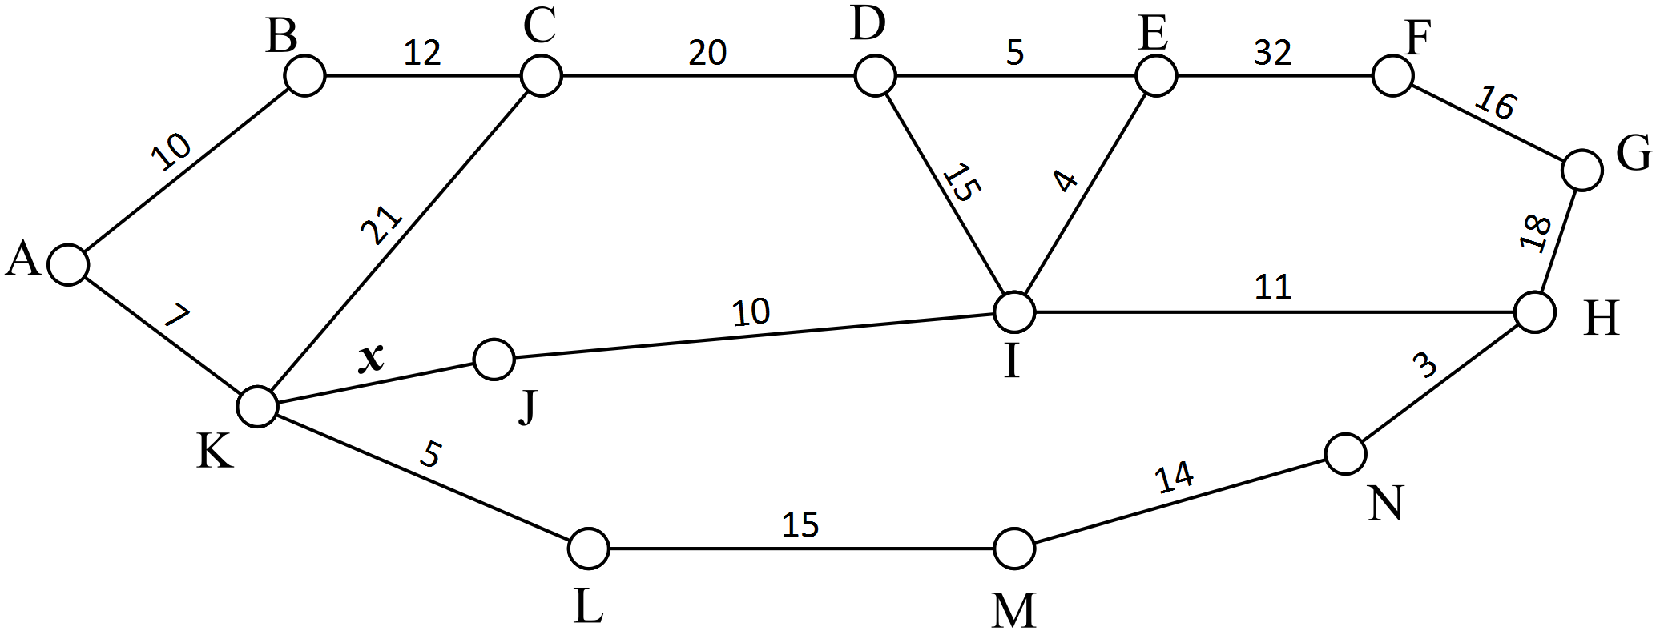

a) Given that $x=10,$ draw in the minimum spanning tree for this network in the diagram above.

Explain what the minimum spanning tree means in the context of this network

b) For $x=10,$ find the shortest route between A and G *passing through* I. Give the length of this

route. Explain what this shortest route means in the context of this question.



c) Given that the shortest path between A and G is AKJIHG, find the value(s) of $x$.



**Question 2. [2, 1, 2, 1: 6 marks]**

The table below shows the cost in thousands of dollars of constructing direct paths between

seven new school buildings.

|  |  |  |  |  |  |  |  |
| --- | --- | --- | --- | --- | --- | --- | --- |
|  | A | B | C | D | E | F | G |
| A | - | 45 | 52 | - | - | 51 | 34 |
| B | 45 | - | 42 | 63 | 31 | 32 | 56 |
| C | 52 | 42 | - | 41 | 40 | - | - |
| D | - | 63 | 41 | - | 43 | 67 | - |
| E | - | 31 | 40 | 43 | - | 30 | 63 |
| F | 51 | 32 | - | 67 | 30 | - | 46 |
| G | 34 | 56 | - | - | 63 | 46 | - |

a) Use Prim’s algorithm to determine the minimum spanning tree.

b) State the cost of building the paths.

c) Draw the minimum spanning tree.

d) If the cost of building the path connecting F to G was reduced by 50% describe the effect on the

minimum spanning tree.

**Question 3. [3, 1, 1, 1, 1: 7 marks]**

A list of tasks for a dinner party is shown in the table below. The time for the preparation of each task is given in minutes.

|  |  |  |  |
| --- | --- | --- | --- |
| Task | Description | Immediate Predecessor | Time |
| A | Shop for food | - | 60 |
| B | Clean house | - | 50 |
| C | Set table | B | 10 |
| D | Prepare mains | A | 20 |
| E | Prepare dessert | A | 40 |
| F | Prepare vegetables | A | 30 |
| G | Cook mains | D | 120 |
| H | Cook vegetables | F | 20 |
| I | Plate food | G | 10 |
| J | Eat main | C,H,I | 60 |
| K | Eat dessert | E,J | 10 |

a) Draw a project network for the activities listed above.

b) List the activities on the critical path.

c) State the minimum completion time.

d) What is the latest time to start preparing the vegetables if mains are to be served at 7p.m.

e) Dessert takes 3 hours to set. How will this affect the minimum completion time?

**Question 4. [7 marks]**

Four students can be entered into a prestigious athletics competition base on 4 running events: 100m, 200m, 400m and 800m. Each student may only enter one of the four events with the winning team having the lowest total time.

Trial times in seconds are recorded in the table below for the top 4 students

|  |  |  |  |  |
| --- | --- | --- | --- | --- |
|  | 100 m | 200 m | 400 m | 800 m |
| Kai | 14 | 25 | 59 | 131 |
| Drew | 12 | 26 | 65 | 159 |
| Lachlan | 18 | 24 | 62 | 175 |
| Brayden | 13 | 27 | 60 | 163 |

Use the Hungarian algorithm to determine which athlete should participate in which event in order to minimise the total time.

**Question 5. [1, 1, 4, 2, 2: 10 marks]**

The road network for a town is shown below. The numbers on the edges represent the maximum number of vehicles that can pass along each road per minute.

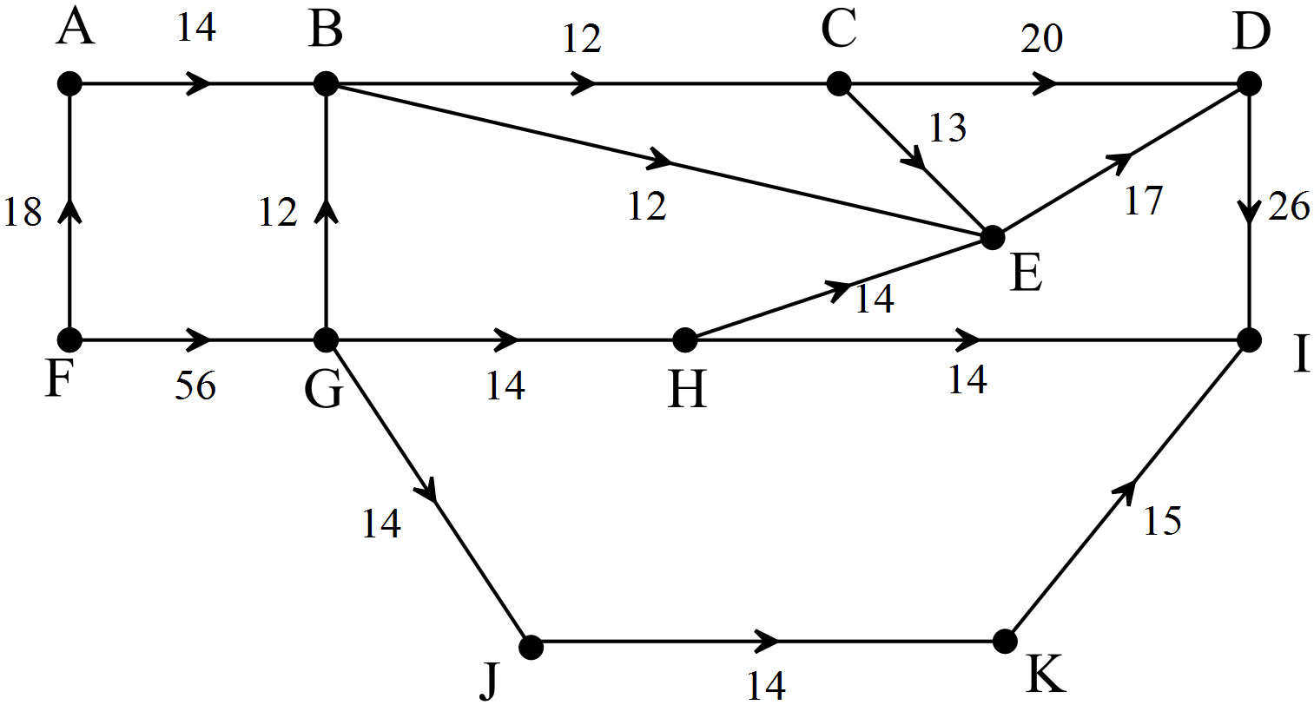

a) Identify the source and sink.

b) Calculate the maximum flow along FGJKL.

c) Calculate the maximum flow from source to sink.

d) Confirm the maximum flow by finding the minimum cut.

e) Traffic flow is to be improved through the town. Which of the three roads BC, GH or JK should be upgraded to maximise flow? Give reasons for your answer,